***DB group project report***22i-0849

22i-1291

22i-0832

Screenshots of the interfaces:

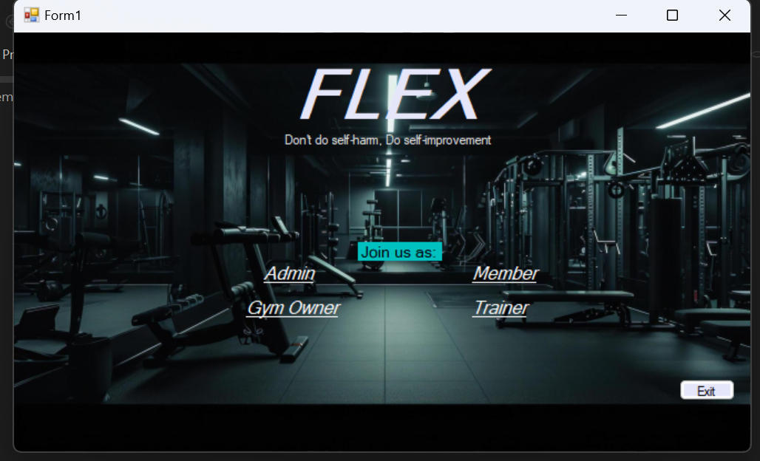

Main page that contains links to all of the main interfaces.

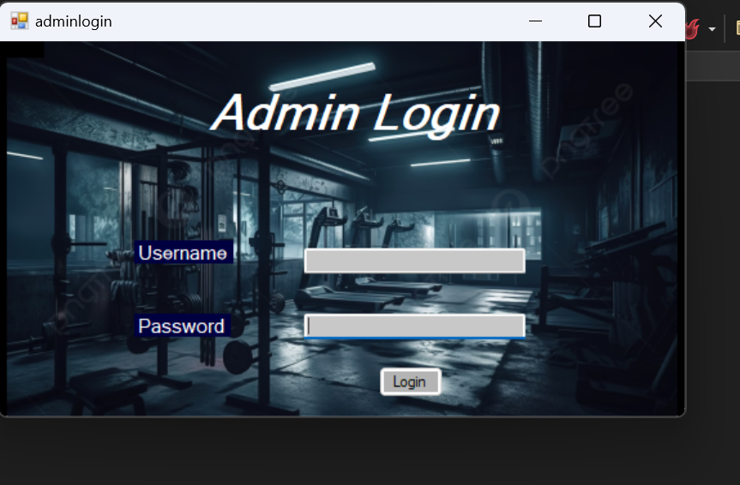

Enables the Admin to login using their username and unique password

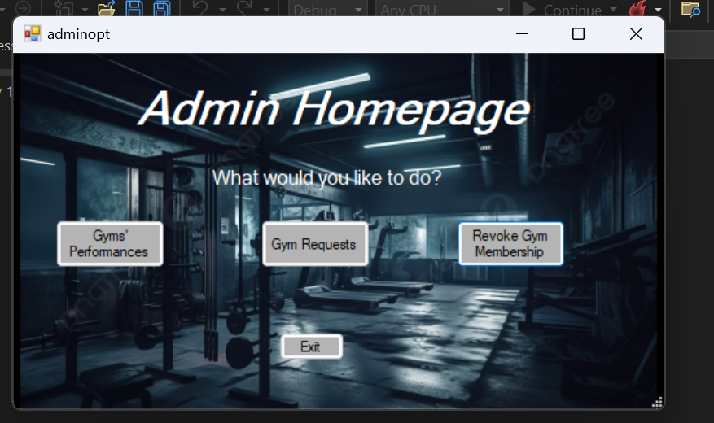

The main admin interface lets the admin perform one of the given above. Buttons are used to navigate through the admin interface options.

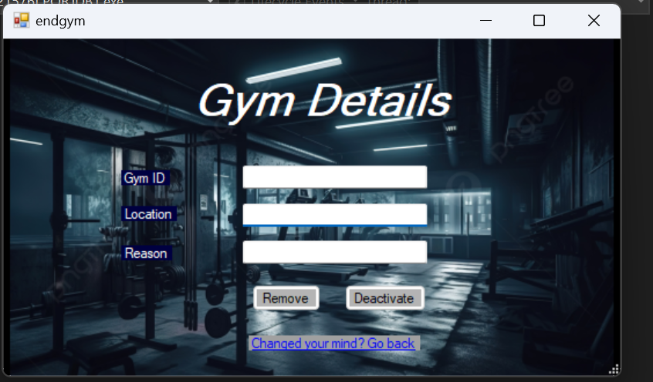

This lets the admin revoke a gym membership to Flex.

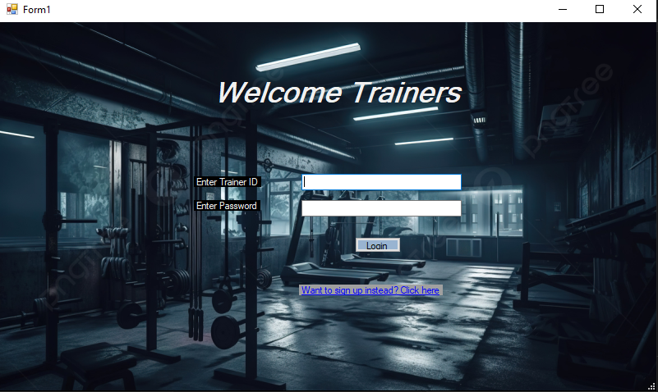

Welcome page for trainer interface user can either login or signup

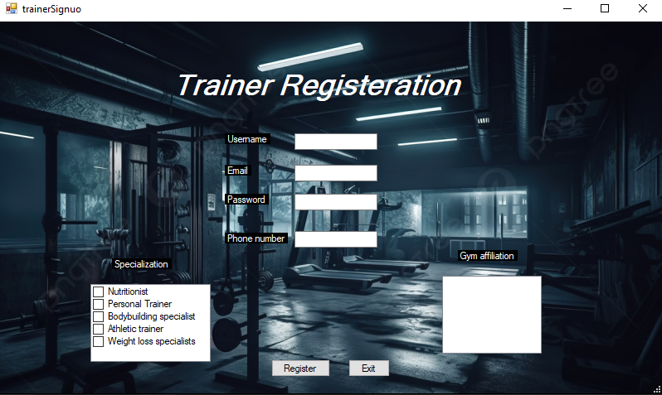

This form lets a new trainer register for the gym. The Gym affiliation box uses a DataGridView tool which will import data from the gym table in the backend.

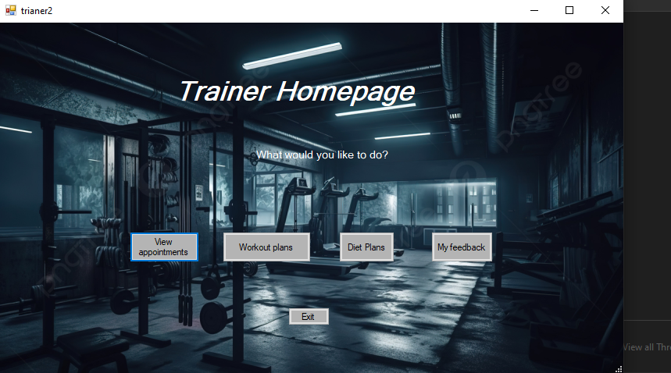

This shows up when login is clicked, there are options as shown above. Buttons are used to navigate between the interfaces.

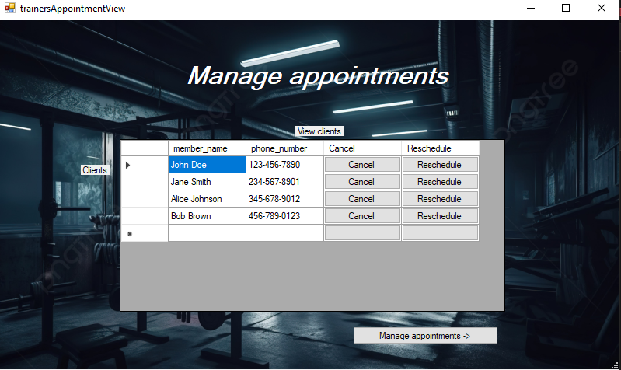

This report shows the Trainer all their clients. DataGrid tool was used to show the contents of tainer_member database

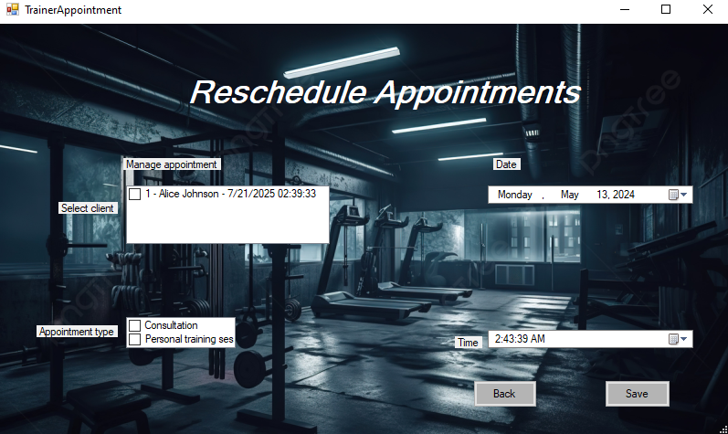This form lets the trainer manage their appointments by selecting client(s). Trainer can select date/time and appointment types. CheckListBox and Dte/Time tool were used.

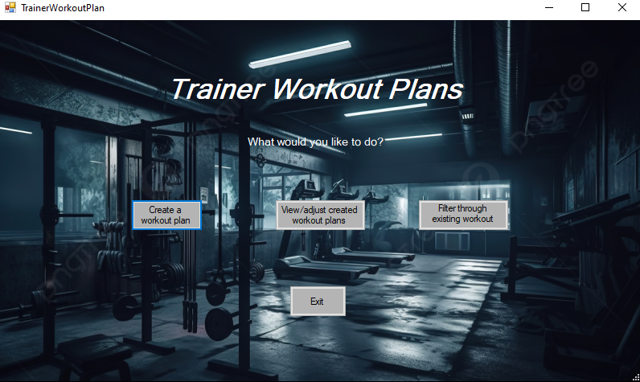This shows when Workout Plan button is clicked in ‘trainer2’ form is clicked. The user may create, view/adjust or filter through the workout plans they created

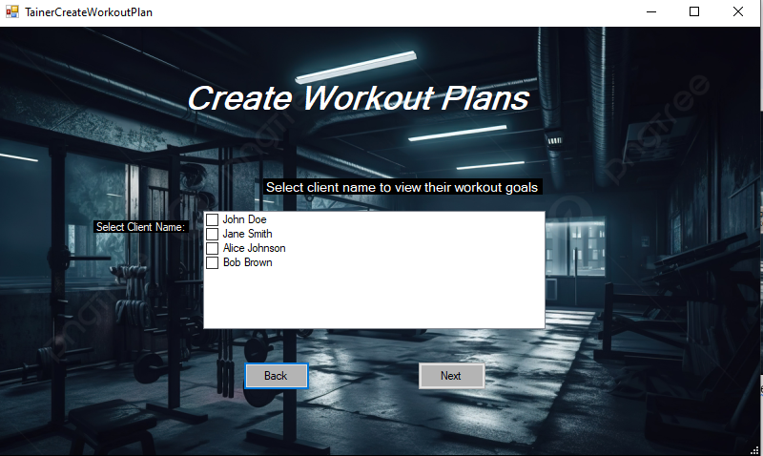

This lets the trainer create workout plans for chosen client. The client info is loaded into DataGridView from the member table in database.

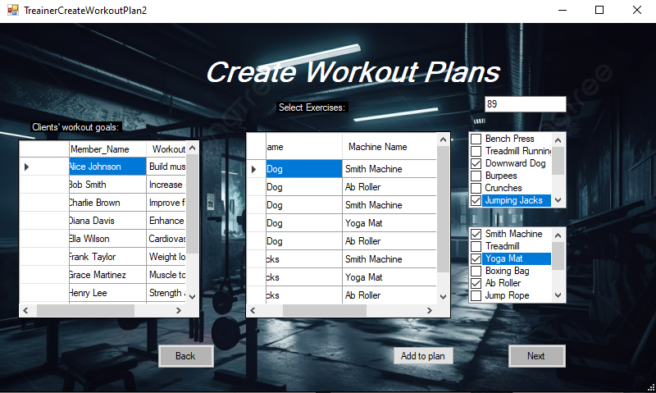This lets trainer create workout plans by selecting Exercises, machines, reps and sets for the chosen client according to their workout/fitness goals.

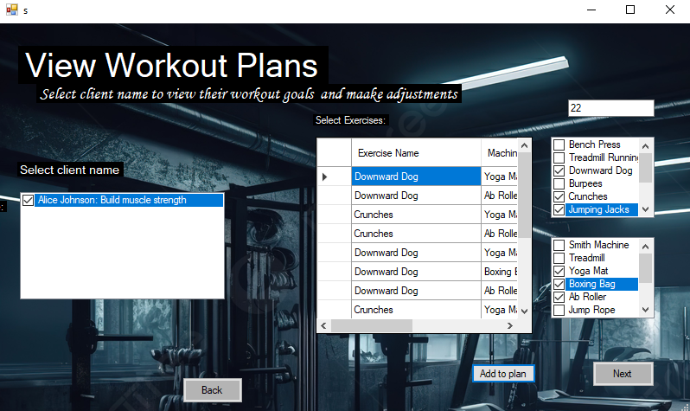

This lets the trainer view their created workout plans and also gives the functionality to make adjustments to the client plans. The empty DataGridView box is the clients workout goals that is to be imported from the concerned table from Flex database. This will be implemented in the backend.

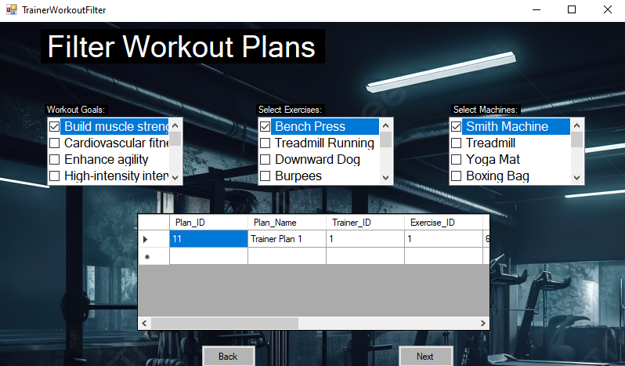

Lets trainer filter through their created workout plans according to the exercises, machines used, time and common client workout goals.

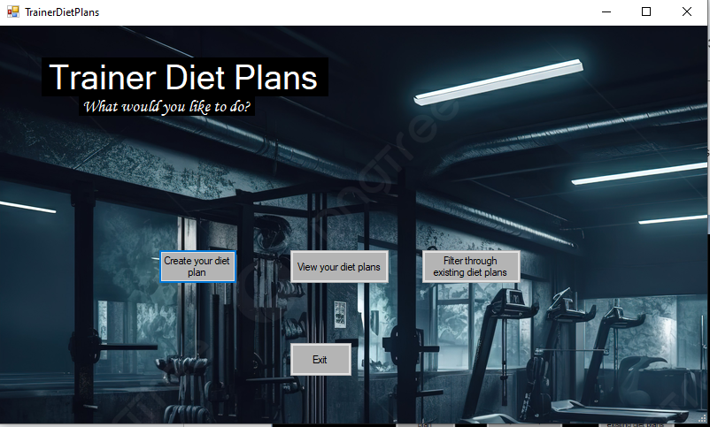

This shows when the button ‘diet plan’ in the ‘trainer2’ form is clicked.

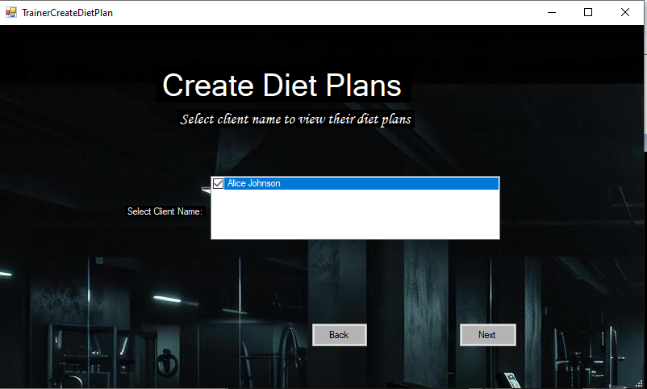

Lets the trainer create Diet plans for the selected client. Makes use of CheckedListBox tool to import data from the database to show the trainer

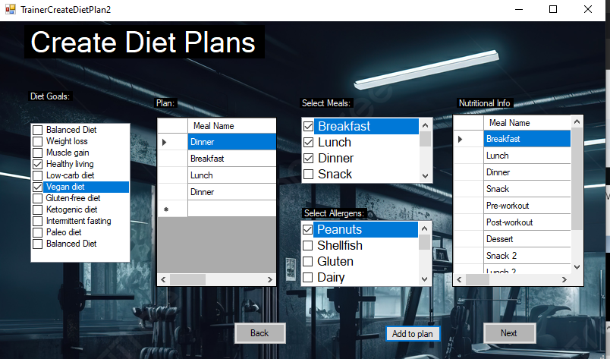

When next Button is clicked from the TrainerCreateDietPlan is clicked the trainer is redirected to this form where the trainer can customize and create the selected clients diet plan according to their diet, fitness goals and allergies if any.

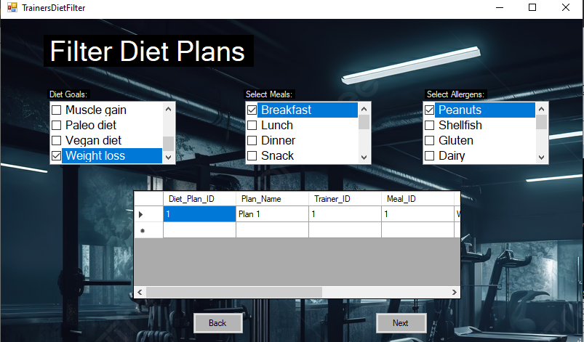

Lets the trainer filter through their created diet plans according to the selected client.

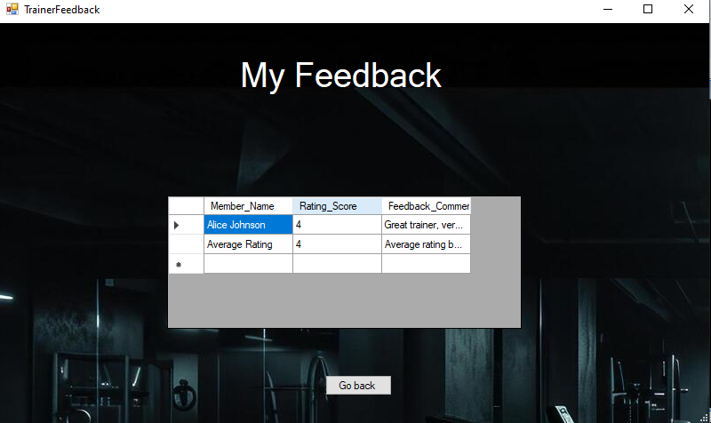

This form lets the trainer view their feedback and ratings from members in the gyms the trainer is affiliated with.

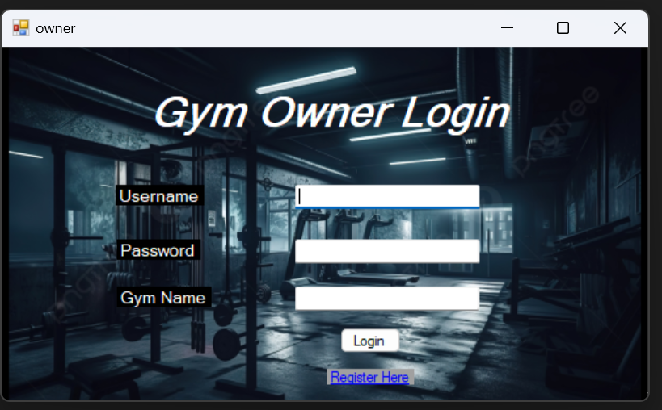

Lets a gym owner login or otherwise register if they already are not registered as a gym owner.Incase of register the following window opens:

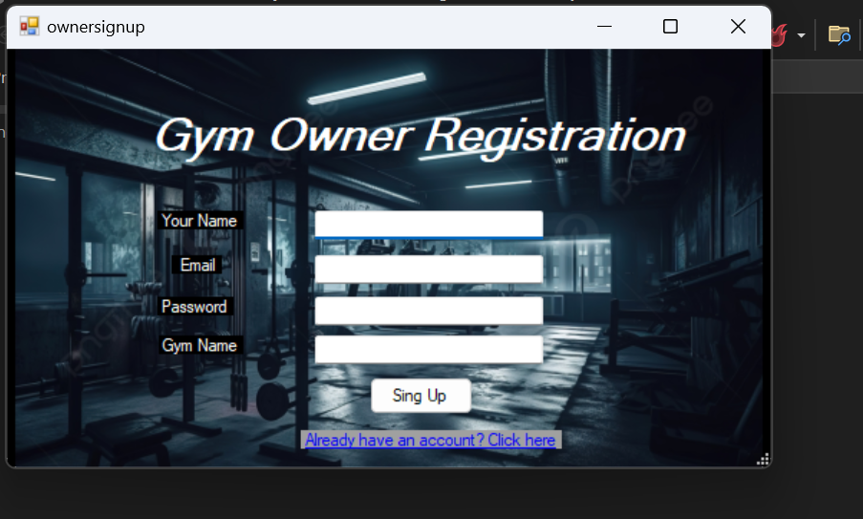

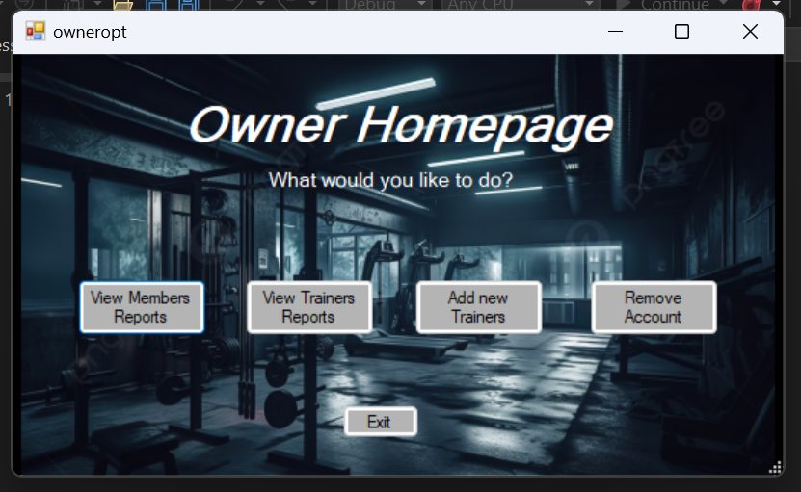

This is the owner homepage that allows owners to choose what action to take. The view options are just to show the reports of the trainers and members.

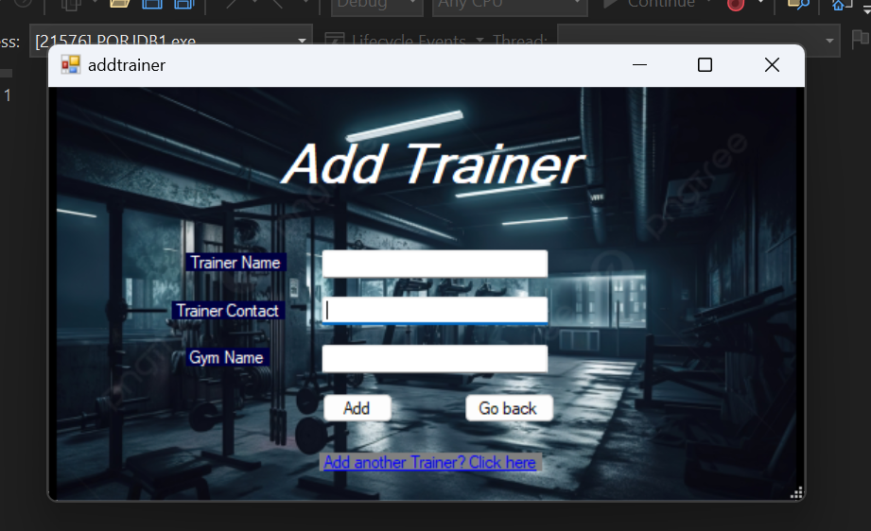

A gym owner can add new trainers to their gyms by their qualifications.

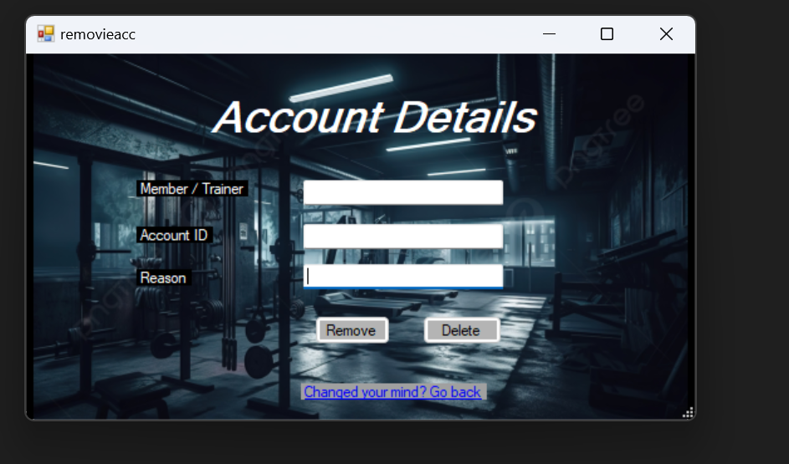

An owner has the authority to remove accounts that have not paid/ other reasons.

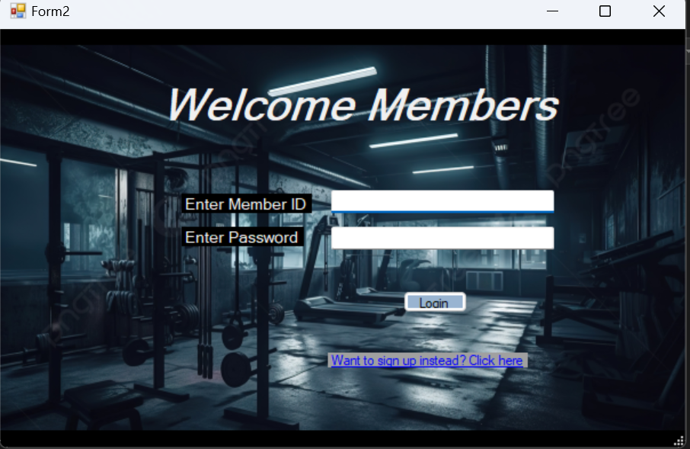

This is the member login page.

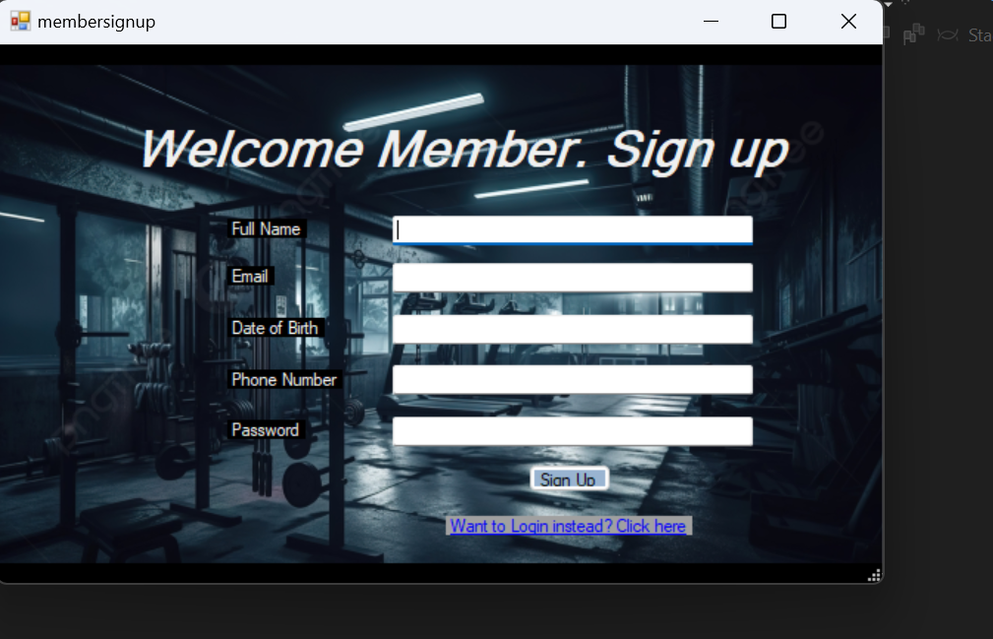

In case they aren't already registered , they can sign themselves up.

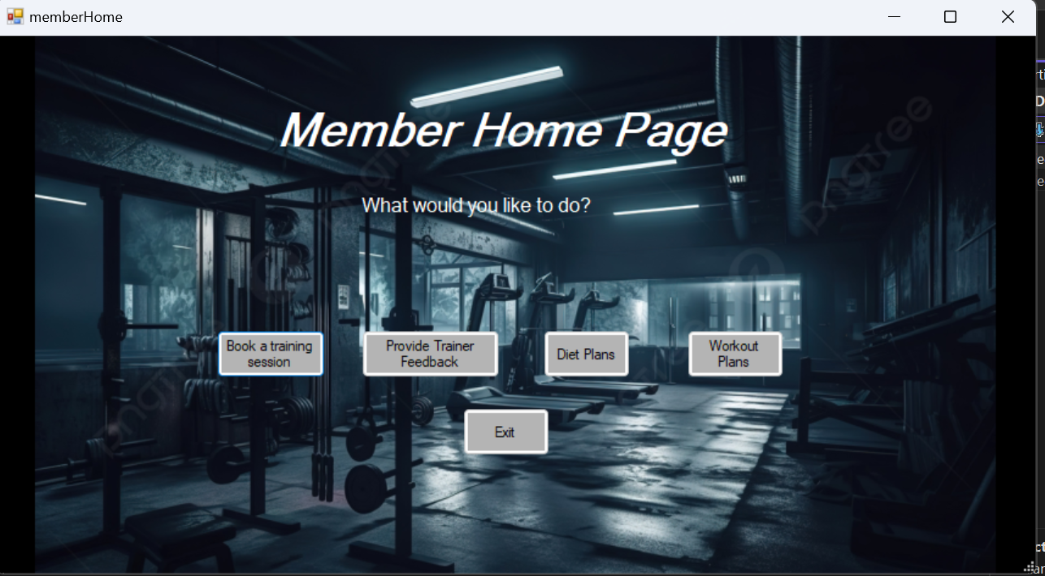

This member homepage gives options to members to choose from.

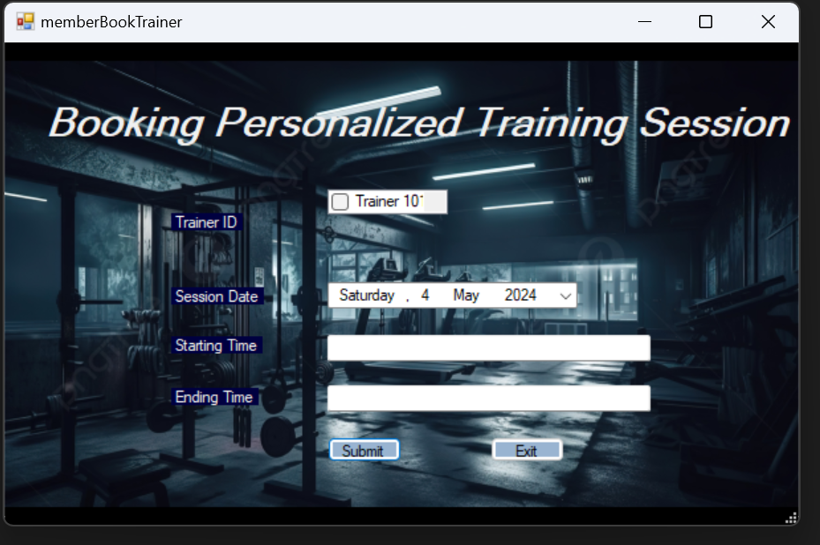

Members can books their own personalized training sessions w/ the trainers.

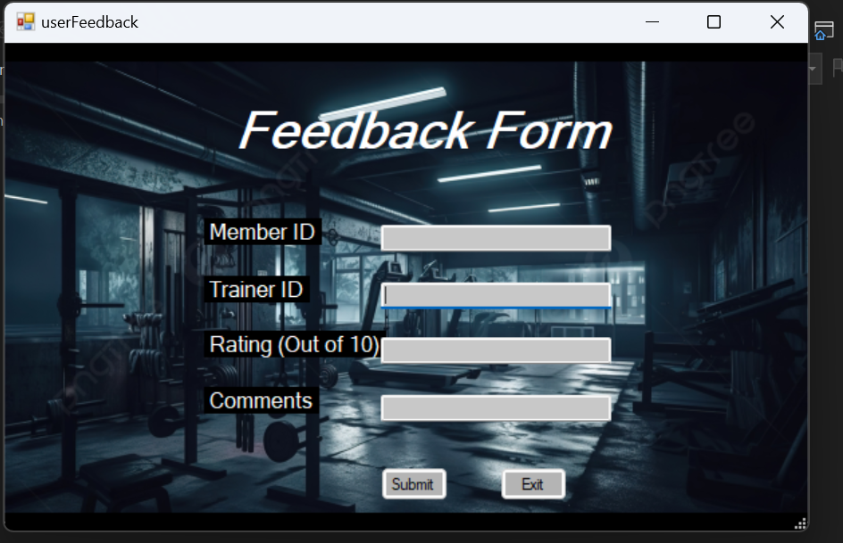

Members can send feedback to different trainers.

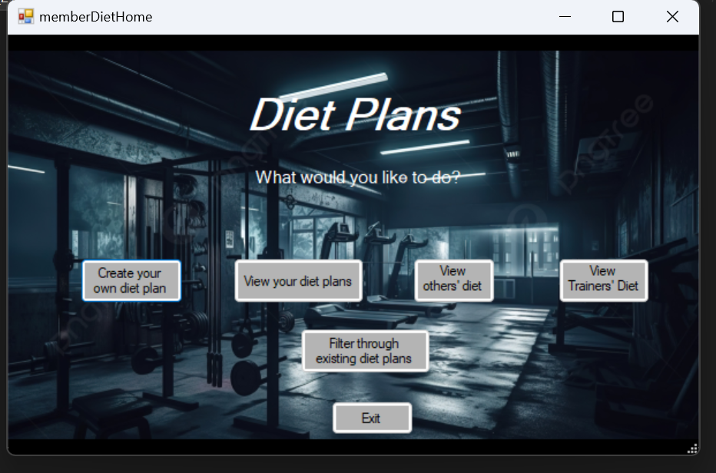

Members have the option to create their diet plans that has further options to choose from.

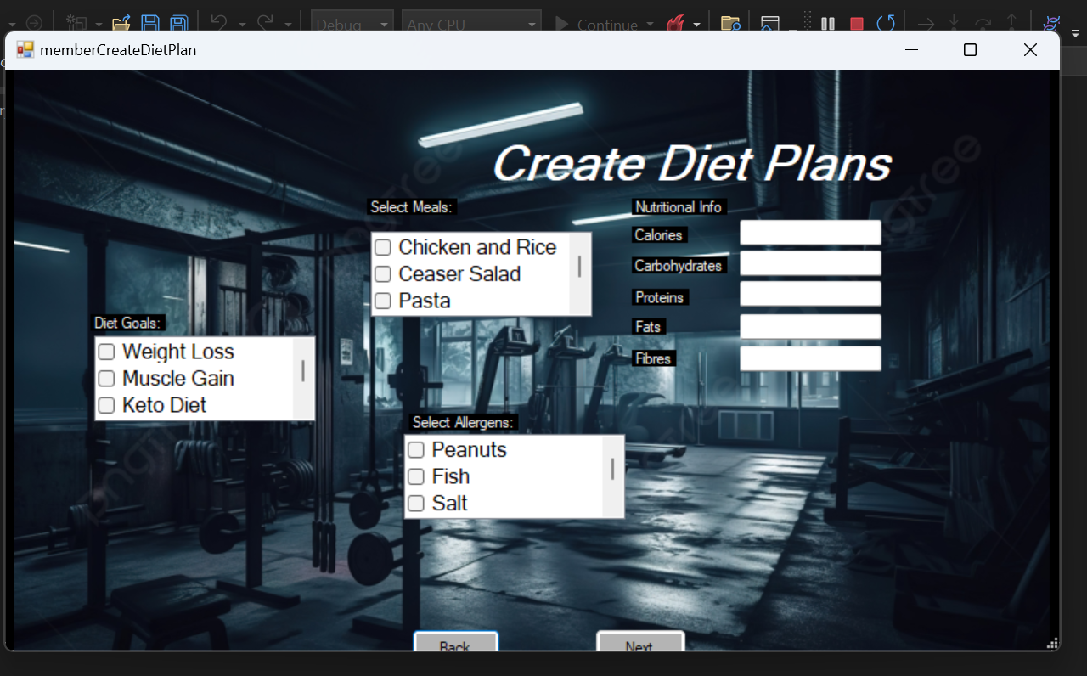

They can optimize their own meals with information like allergies etc.

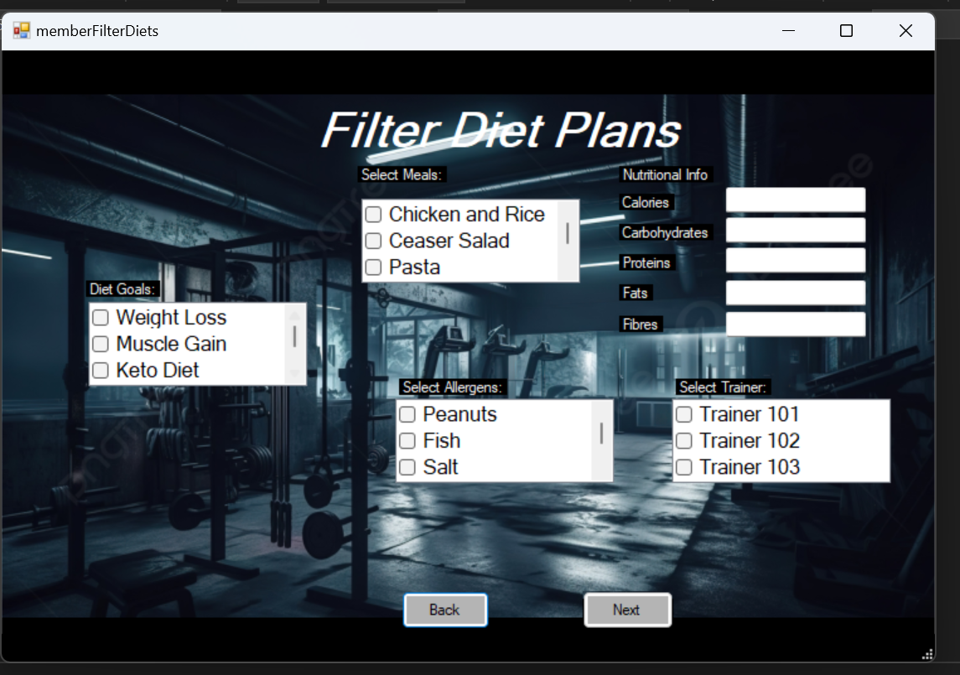

They can choose from the existing meals that match their preferences using the filter form

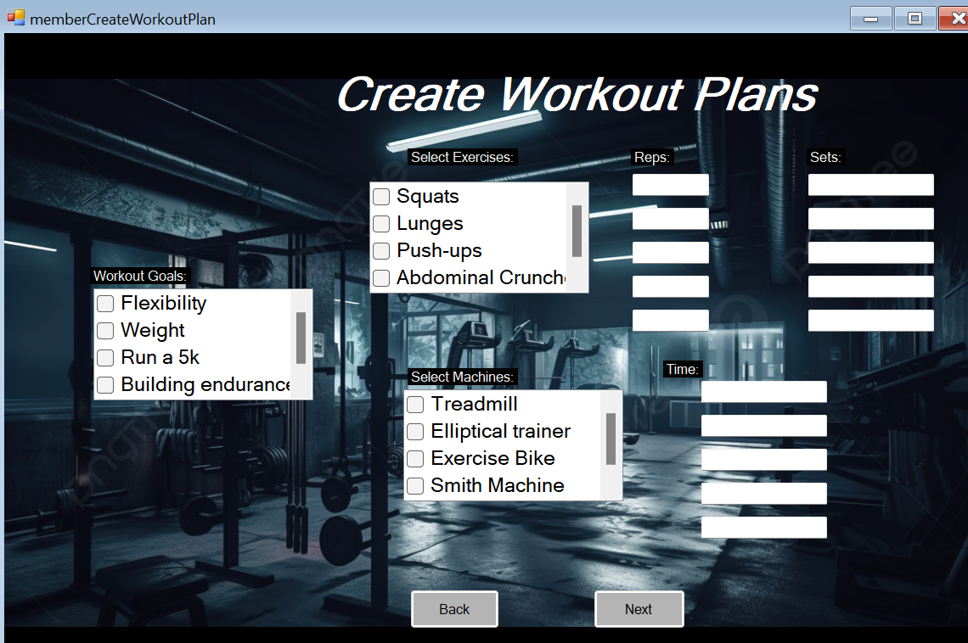

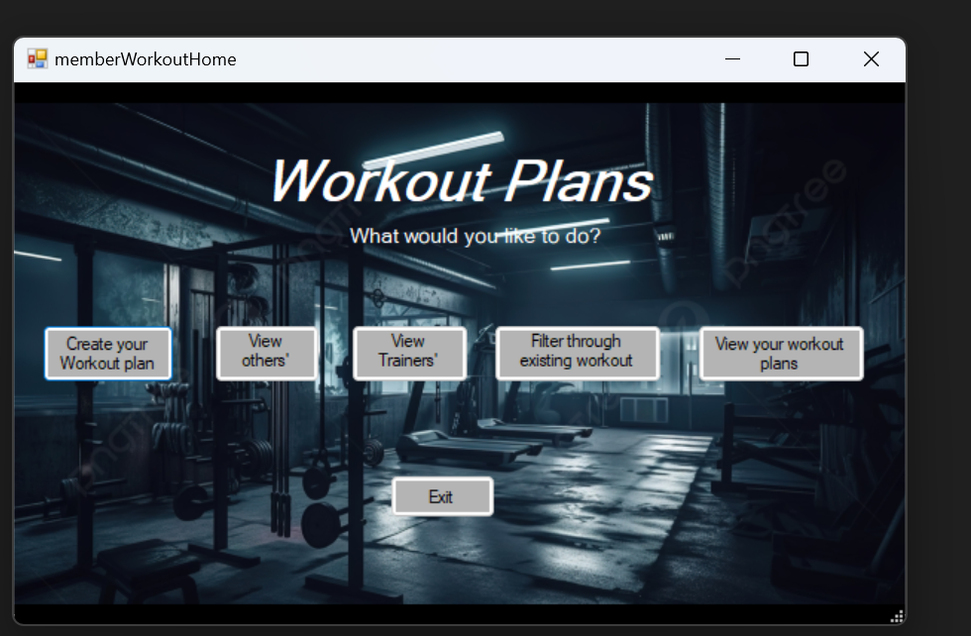

Members can also customize their workout plans. They can view reports of different trainers and view their own workouts.

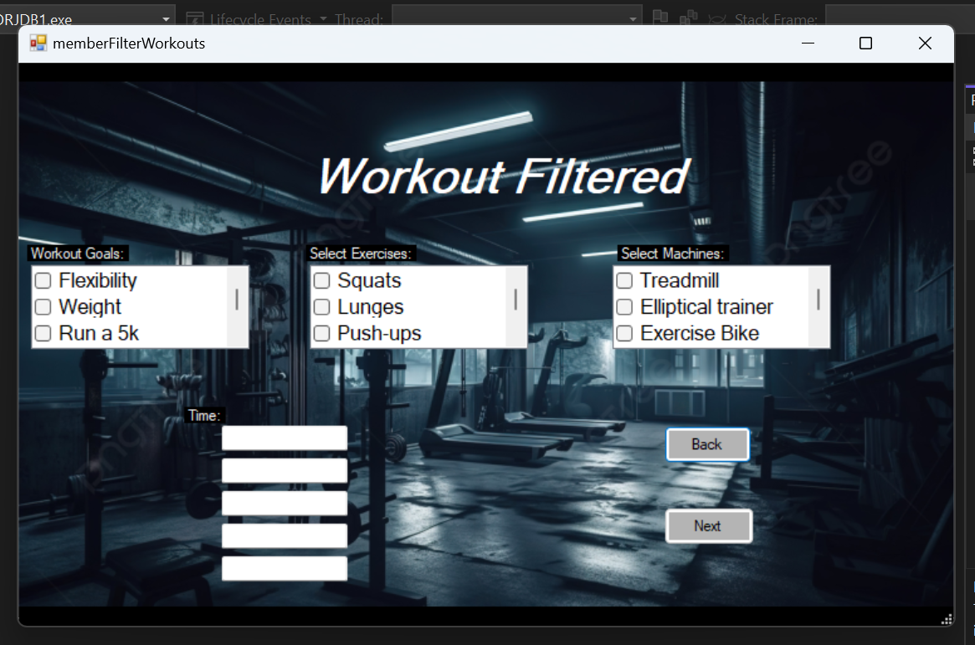

They can choose from the existing workouts using filter form to choose what is best for them.

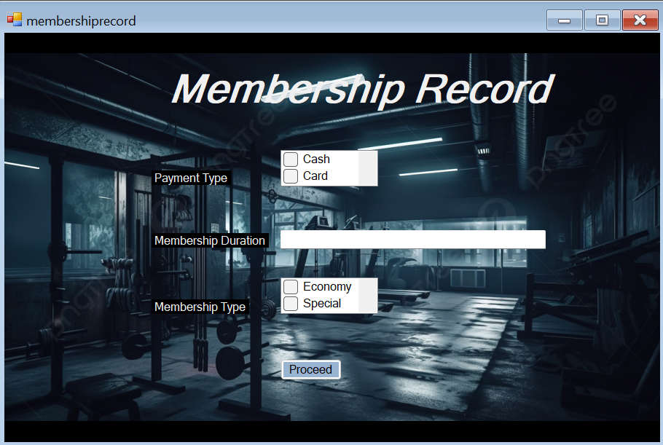

Membership records form hold the information of the payment and their membership in the gym.